**BLUE DART DATA Analysis**

**Over-Viewing the data**

SELECT * FROM ORDER_DETAILS

SELECT * FROM ORDERS

SELECT * FROM PRODUCTS

SELECT * FROM SHIPPERS

SELECT * FROM SUPPLIERS

SELECT * FROM CATEGORIES

SELECT * FROM EMPLOYEE_DETAILS

**KPI’s Analysis**

1. **Total Revenue**

SELECT FORMAT(SUM(OD.QUANTITY * P.PRICE),'C','EN-US') AS TOTAL_REVENUE

FROM ORDER_DETAILS AS OD JOIN PRODUCTS AS P ON OD.PRODUCTID = P.PRODUCTID

**OUTPUT:**



1. **Total Orders**

SELECT COUNT(ORDERID) AS TOTAL_ORDERS FROM ORDER_DETAILS

**OUTPUT:**



1. **Total Quantity**

SELECT SUM(QUANTITY) AS TOTAL_QUANTITY FROM ORDER_DETAILS

**OUTPUT:**



1. **Showcasing Employees Name, Employee ID, Qualifications and Age**

SELECT NAME, EMPLOYEEID, AGE, QUALIFICATION FROM EMPLOYEE_DETAILS ORDER BY AGE

**OUTPUT:**

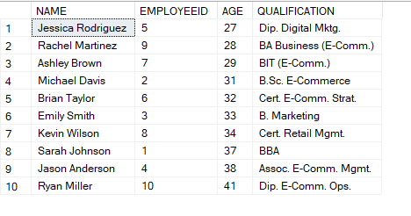

1. **Showcasing Shippers Name, Rate, Carrier Type, Service Coverage**

SELECT SHIPPERSNAME, [RATES ], [CARRIER TYPE], [SERVICE COVERAGE] FROM SHIPPERS

**OUTPUT:**

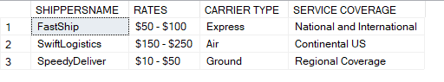

1. **Suppliers Count by Country**

SELECT COUNTRY, COUNT(SUPPLIERID) AS TOTAL_SUPPLIERS FROM SUPPLIERS GROUP BY COUNTRY

**OUTPUT:**

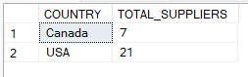

1. **Revenue by Each Year**

SELECT DATEPART(YEAR,O.ORDERDATE) AS YEAR,

FORMAT(SUM(OD.QUANTITY * P.PRICE),'C','EN-US') AS TOTAL_REVENUE

FROM ORDER_DETAILS AS OD JOIN ORDERS AS O ON OD.ORDERID = O.ORDERID

JOIN PRODUCTS AS P ON OD.PRODUCTID = P.PRODUCTID

GROUP BY DATEPART(YEAR,O.ORDERDATE)

ORDER BY YEAR

**OUTPUT:**

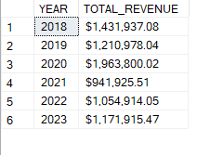

1. **Revenue by Each Quarter for Every Year**

SELECT SQ.YEAR,

FORMAT(SUM(CASE WHEN SQ.YEAR_QUARTER = 1 THEN SQ.TOTAL_REVENUE ELSE 0 END),'C','EN-US') AS Q1_REVENUE,

FORMAT(SUM(CASE WHEN SQ.YEAR_QUARTER = 2 THEN SQ.TOTAL_REVENUE ELSE 0 END),'C','EN-US') AS Q2_REVENUE,

FORMAT(SUM(CASE WHEN SQ.YEAR_QUARTER = 3 THEN SQ.TOTAL_REVENUE ELSE 0 END),'C','EN-US') AS Q3_REVENUE,

FORMAT(SUM(CASE WHEN SQ.YEAR_QUARTER = 4 THEN SQ.TOTAL_REVENUE ELSE 0 END),'C','EN-US') AS Q4_REVENUE

FROM(SELECT DATEPART(YEAR,O.ORDERDATE) AS YEAR,

DATEPART(QUARTER,O.ORDERDATE) AS YEAR_QUARTER,

SUM(OD.QUANTITY * P.PRICE) AS TOTAL_REVENUE

FROM ORDER_DETAILS AS OD JOIN ORDERS AS O ON OD.ORDERID = O.ORDERID

JOIN PRODUCTS AS P ON OD.PRODUCTID = P.PRODUCTID

GROUP BY DATEPART(YEAR,O.ORDERDATE),DATEPART(QUARTER,O.ORDERDATE)) AS SQ

GROUP BY SQ.YEAR

ORDER BY SQ.YEAR

**OUTPUT:**

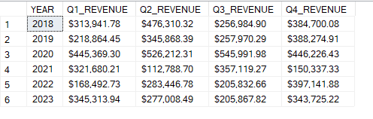

1. **Top 5 Products sold by Quantity**

SELECT TOP 5 OD.PRODUCTID, P.PRODUCTNAME, SUM(OD.QUANTITY) AS TOTAL_QUANTITY

FROM ORDER_DETAILS AS OD JOIN PRODUCTS AS P ON OD.PRODUCTID = P.PRODUCTID

GROUP BY OD.PRODUCTID, P.PRODUCTNAME

ORDER BY TOTAL_QUANTITY DESC

**OUTPUT:**

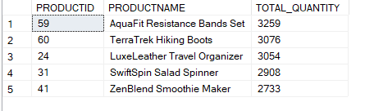

1. **Bottom 5 Products sold by Quantity**

SELECT TOP 5 OD.PRODUCTID, P.PRODUCTNAME, SUM(OD.QUANTITY) AS TOTAL_QUANTITY

FROM ORDER_DETAILS AS OD JOIN PRODUCTS AS P ON OD.PRODUCTID = P.PRODUCTID

GROUP BY OD.PRODUCTID, P.PRODUCTNAME

ORDER BY TOTAL_QUANTITY

**OUTPUT:**

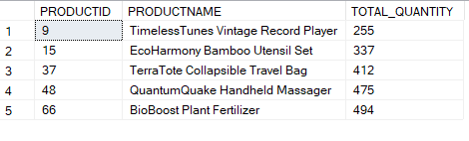

1. **5 High Revenue Generated Products**

SELECT TOP 5 OD.PRODUCTID, P.PRODUCTNAME,

FORMAT(SUM(OD.QUANTITY * P.PRICE),'C','EN-US') AS TOTAL_REVENUE

FROM ORDER_DETAILS AS OD JOIN PRODUCTS AS P ON OD.PRODUCTID = P.PRODUCTID

GROUP BY OD.PRODUCTID, P.PRODUCTNAME

ORDER BY SUM(OD.QUANTITY * P.PRICE) DESC

**OUTPUT:**

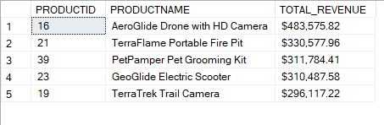

1. **5 Low Revenue Generated Products**

SELECT TOP 5 OD.PRODUCTID, P.PRODUCTNAME,

FORMAT(SUM(OD.QUANTITY * P.PRICE),'C','EN-US') AS TOTAL_REVENUE

FROM ORDER_DETAILS AS OD JOIN PRODUCTS AS P ON OD.PRODUCTID = P.PRODUCTID

GROUP BY OD.PRODUCTID, P.PRODUCTNAME

ORDER BY SUM(OD.QUANTITY * P.PRICE)

**OUTPUT:**

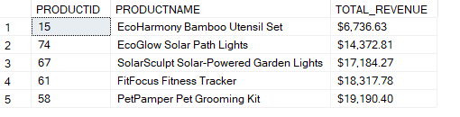

1. **5 Most Ordered Products**

SELECT TOP 5 OD.PRODUCTID, P.PRODUCTNAME, COUNT(OD.ORDERID)AS TOTAL_ORDERS

FROM ORDER_DETAILS AS OD JOIN PRODUCTS AS P ON OD.PRODUCTID = P.PRODUCTID

GROUP BY OD.PRODUCTID, P.PRODUCTNAME

ORDER BY TOTAL_ORDERS DESC

**OUTPUT:**

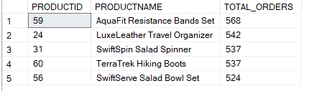

1. **5 Least Ordered Products**

SELECT TOP 5 OD.PRODUCTID, P.PRODUCTNAME, COUNT(OD.ORDERID)AS TOTAL_ORDERS

FROM ORDER_DETAILS AS OD JOIN PRODUCTS AS P ON OD.PRODUCTID = P.PRODUCTID

GROUP BY OD.PRODUCTID, P.PRODUCTNAME

ORDER BY TOTAL_ORDERS

**OUTPUT:**

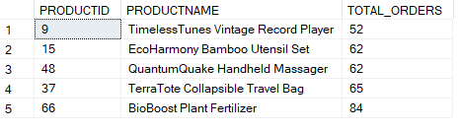

1. **Sales by Category**

SELECT P.CATEGORYID, C.CATEGORYNAME, COUNT(OD.ORDERID) AS TOTAL_ORDERS,

FORMAT(SUM(OD.QUANTITY * P.PRICE),'C','EN-US') AS TOTAL_REVENUE

FROM ORDER_DETAILS AS OD JOIN PRODUCTS AS P ON OD.PRODUCTID = P.PRODUCTID

JOIN CATEGORIES AS C ON P.CATEGORYID = C.CATEGORYID

GROUP BY P.CATEGORYID, C.CATEGORYNAME

ORDER BY TOTAL_ORDERS

**OUTPUT:**

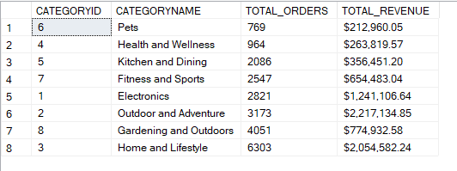

1. **Most Used Payment Method**

SELECT O.[PAYMENT MODE], COUNT(O.[PAYMENT MODE]) AS NO_OF_PAYMENTS

FROM ORDER_DETAILS AS OD JOIN ORDERS AS O ON OD.ORDERID = O.ORDERID

GROUP BY O.[PAYMENT MODE]

ORDER BY NO_OF_PAYMENTS DESC

**OUTPUT:**

